**SUMMARY**

As an experienced DevOps Engineer and Web Developer, comprising to build Robust Application with Security and Scalability as a key factor while development. Extensive experience includes Build/Release Management, Change/Incident Management, site reliability, managing containers. Written terraform, bicep, ARM etc. configuration files to Provision Several pre­production environments.

**CORE COMPETENCIES**

NodeJS, MongoDB, MySQL. ReactJS. Configuration Management: Chef, Puppet. Cloud Computing: Azure, Scripting Languages: Shell, PowerShell, JavaScript. Source Code Management: Subversion, TFS, Git, Perforce CI Tools: Jenkins, Bamboo, Azure Devops, CircleCI, GitHub Actions Operating Systems: Windows, Linux and Databases: SQL Server, Oracle, MySQL. DevSecOps Tools: WhiteSource Bolt, SonarQube and many other DAST tools.

**PROFESSIONAL EXPERIENCE**

# DevOps Engineer

**Key Deliverables:**

* Providing configuration management expertise to all software development projects.
* Automation of Dotnet, Node, React, Angular, PHP applications to achieve continuous integration and continuous delivery (ci and cd). That helped to reduce the deployment time by more that 60 percent.
* Managing cloud environment and monitoring of that environment in most efficient way and notification alert at any failure.
* Developing and deploying microservices application.
* Expertise in docker containerization and a good hands-on Kubernetes.
* Experience with different IaaC tools like Terraform, Ansible, Chef, Puppet, Bicep, ARM etc.
* Worked with different cloud platforms: Azure, AWS, GCP, Digital Ocean, Vercel, Netlify.
* Basic understanding of networking and security.
* Strong understating of application security.

# Web Development

* I have experience in Frontend: React and Backend: Nodejs, Database: MySQL, MS SQL and MongoDB.
* Developed an Inventory management application, using React, NodeJS and MySQL and deployed that on Azure Web App and using Azure Devops for CI/CD.
* Optimized the application to prevent SQLi and Session Hijacking.
* Cannot share the application url, but I can share the image. Please checkout below image.
* 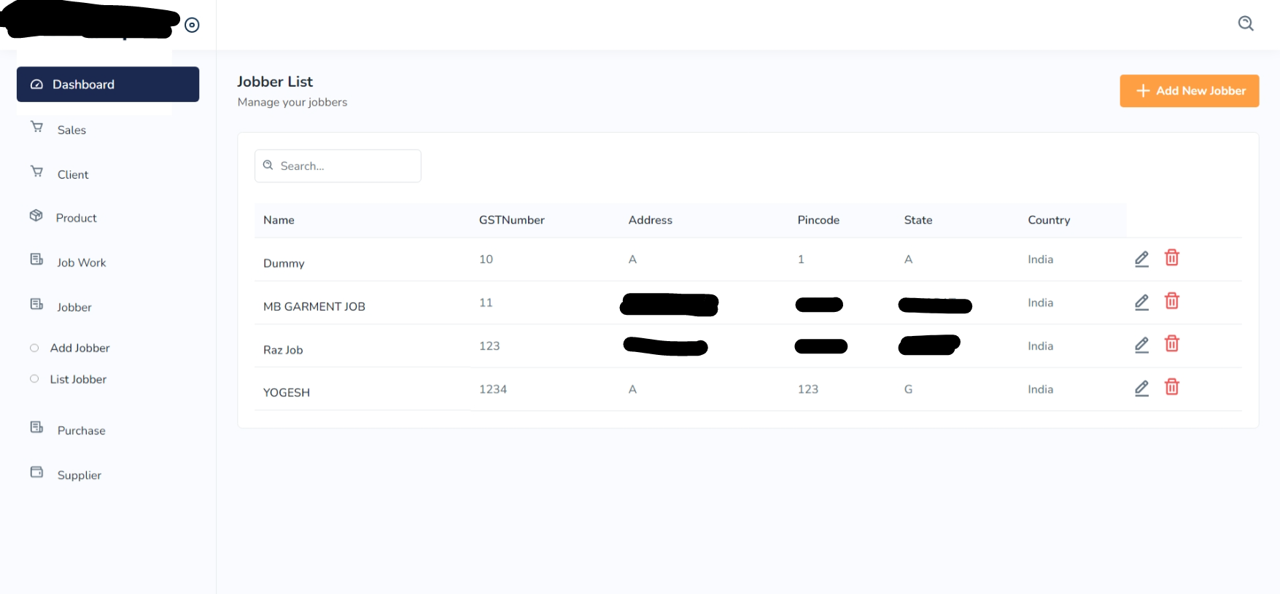

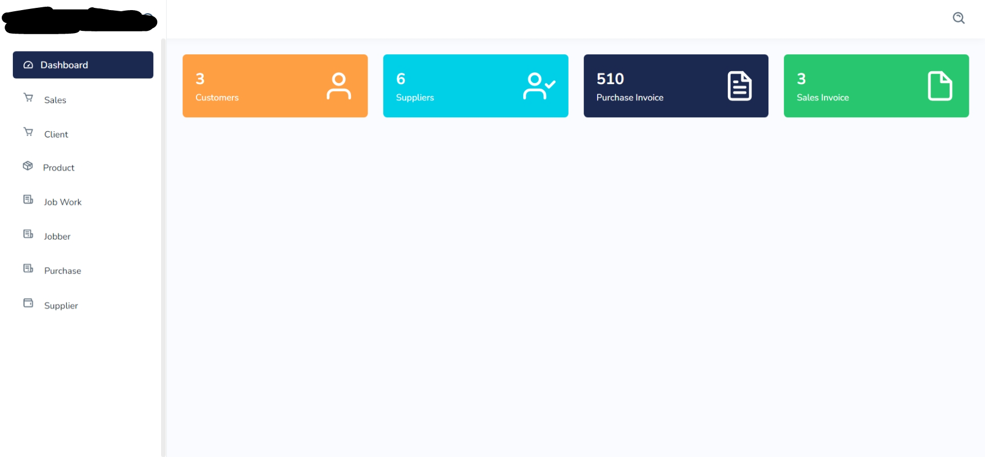

Certainly! If you want to learn more about the challenges I faced and the solutions I implemented to overcome them, you can visit my Upwork profile at <https://www.upwork.com/freelancers/~019130483bb4304c90?p=1637107986491600896>. There, you will find more information about my work experience and the projects I have completed.

**Automation/Scripting**

* I have years of experience in automation applications using **Node.js** and **Puppeteer**.
* I have used Puppeteer to extract information like **phone numbers, email addresses**, ratings, reviews, etc. from **Google Maps**. For example, to extract information on "Best Restaurants in New York".
* In one of the projects, I worked on, I used Puppeteer to **crawl the entire application** and record URLs that it visited. On each visited page, the application recorded all the **HTTP requests** it made, and we performed some very complex operations on the data we recorded, which I cannot share here.
* I have also used Node.js and Puppeteer to **automate LinkedIn** using its APIs.

**CERTIFICATION**

* AZ 400: Designing and Implementing Microsoft DevOps Solutions.

<https://www.credly.com/badges/5e1b68b9-98eb-4c50-935f-9f568103c4d5?source=linked_in_profile>

* AZ 204: Developing Solutions for Microsoft Azure.

<https://www.credly.com/badges/a806c881-bda9-4602-9594-f5694c62e1c2/linked_in_profile>

* Microsoft Certified: Devops Engineer Expert.

<https://www.credly.com/badges/9ece9ea8-f42b-4470-a763-dc508b591929/linked_in_profile>

**EDUCATION**

* Bachelors ­ LDRP Gandhinagar in Computer Science ­ 2018-2022
* Higher Secondary- St. Xavier’s Hansol- 2016-2018
* Secondary- Delhi Public School (DPS) Gandhinagar.